SOLVEDOKU
(SDK)

CS 3337 Software Engineering

Functional Requirements and Design Document

Prepared by

Kevin Trang
Allen Ruan
Nikita Aggarwal
Brandon Lee

APR 16, 2018

Table of Contents

List of Figures

Figure 1-1 Context Diagram (Level 0 Data Flow Diagram)
Figure 2-1 Level 1 Data Flow Diagram

List of Tables

None.
1.0 INTRODUCTION

1.1 Purpose

The purpose of this document is four-fold:

a) Define a full set of requirements for SOLVEDOKU.

b) Define the design for SOLVEDOKU.

c) Define the implementation of SOLVEDOKU.

d) Define the Test Plan for SOLVEDOKU.

The complete definition of all SOLVEDOKU requirements provides the requirements to be used in the subsequent software subsystem documents.

1.2 Scope

This documentation was developed as part of a Software Engineering class, CS 3337.

The scope of this document includes the following:

- All functional and non-functional requirements. These requirements are organized by key SOLVEDOKU functional units shown in DFD 1

- Functional descriptions of each of the modules of SOLVEDOKU.

- General descriptions of hardware necessary for implementation of SOLVEDOKU.

1.2.1 Document Organization

The organization of this document provides a natural 'flow' or allocation of requirements to each succeeding section. Details regarding the overall document structure are discussed in sub-section 1.4.

1.2.2 Relationship to Other Documents

The SOLVEDOKU SRD/SDD/STP/SID is a complete self-contained document. However, Java code is included in separate files. Some relationships to other documents in the literature are indicated below in sub-section 1.5.

1.3 Project Name Architecture

1.3.1 Context Diagram (DFD Level 0)

SOLVEDOKU’s architecture is summarized in the Context Diagram (DFD Level 0) given below. A more detailed Functional Description is given in Section 2 of this document.
Figure 1-1: Level 0 DFD

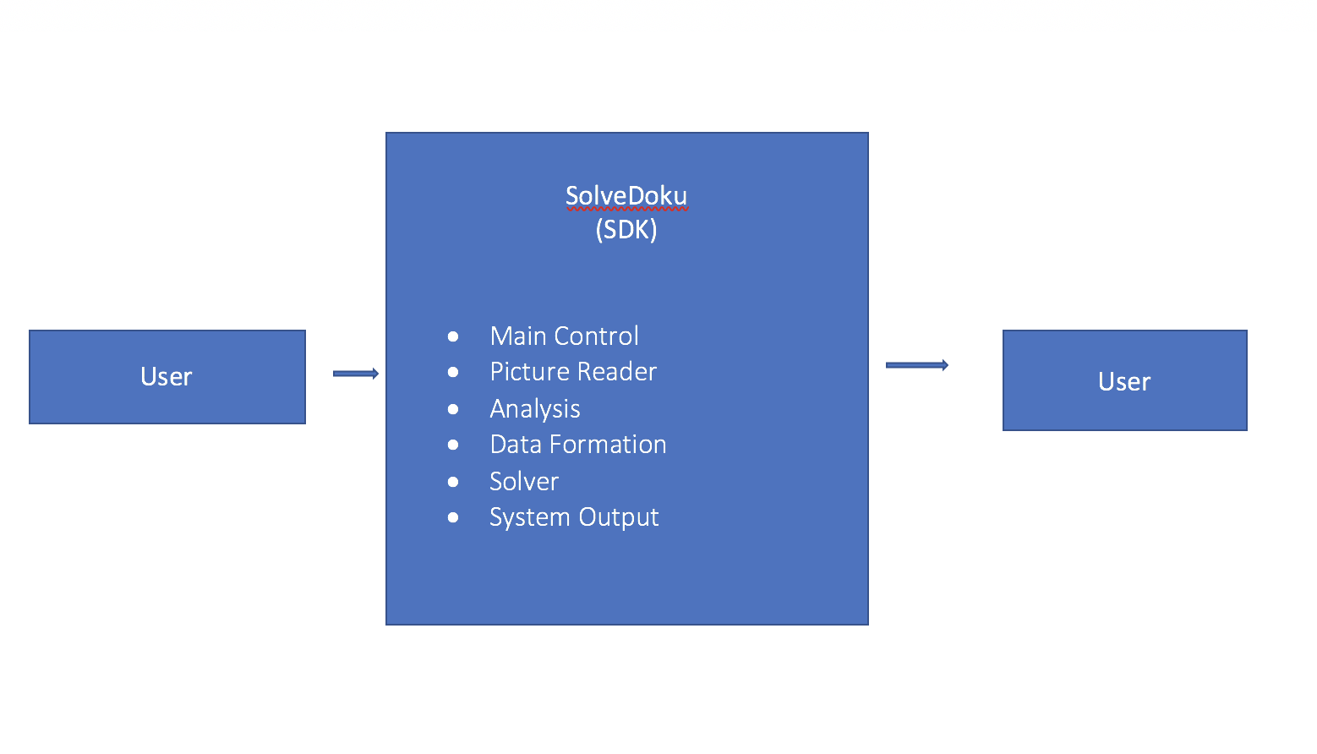

1.3.2 Description and Major Functions of SOLVEDOKU

SOLVEDOKU automates the solving process of a Sudoku puzzle. The system offers the ability to upload an image and have it solved using image recognition. SOLVEDOKU recognizes the image and stores all the digits and uses backtracking to solve the 9x9 puzzle. SOLVEDOKU is controlled by a GUI. The name SOLVEDOKU is a combination between the famous Sudoku puzzle and the word solve.

1.3.3 Hardware and Software Considerations

SOLVEDOKU requires standard computer hardware. Other software requirements includes the latest build of Oracle’s Java Runtime Environment.

1.4 Documentation of the Development Process

SOLVEDOKU’s detailed functional description is documented in section 2.0. Section 2 is a succinct software description document. The overall detailed functional description is based on higher level DFDs (above level 1). All major functional units are described in detail in this part of the document.

Requirements for SOLVEDOKU are captured in Section 3.0 of this document. This section includes both functional and non-functional software requirements, supplemented with more detailed information when necessary.

1.5 References

All references used in the creation of this document are listed below.

1.5.1 Controlling Documents

N/A

1.5.2 Applicable Documents

N/A

1.5.3 Standards

N/A

2.0 DETAILED FUNCTIONAL DESCRIPTION OF SOLVEDOKU

2.1 Detailed SOLVEDOKU Functional Description.

The major tool used to design SOLVEDOKU is the Data Flow Diagram, DFD. The rationale for the selection of DFDs as the preferred design tool is its simplicity and versatility. In the future additional tools may be used if a stronger correlation from Design to Requirement to Implementation and Testing is required.

2.1.1 Level 1 DFD

SolveDoku’s major functional subunits are shown in the DFD Level 1 shown below:
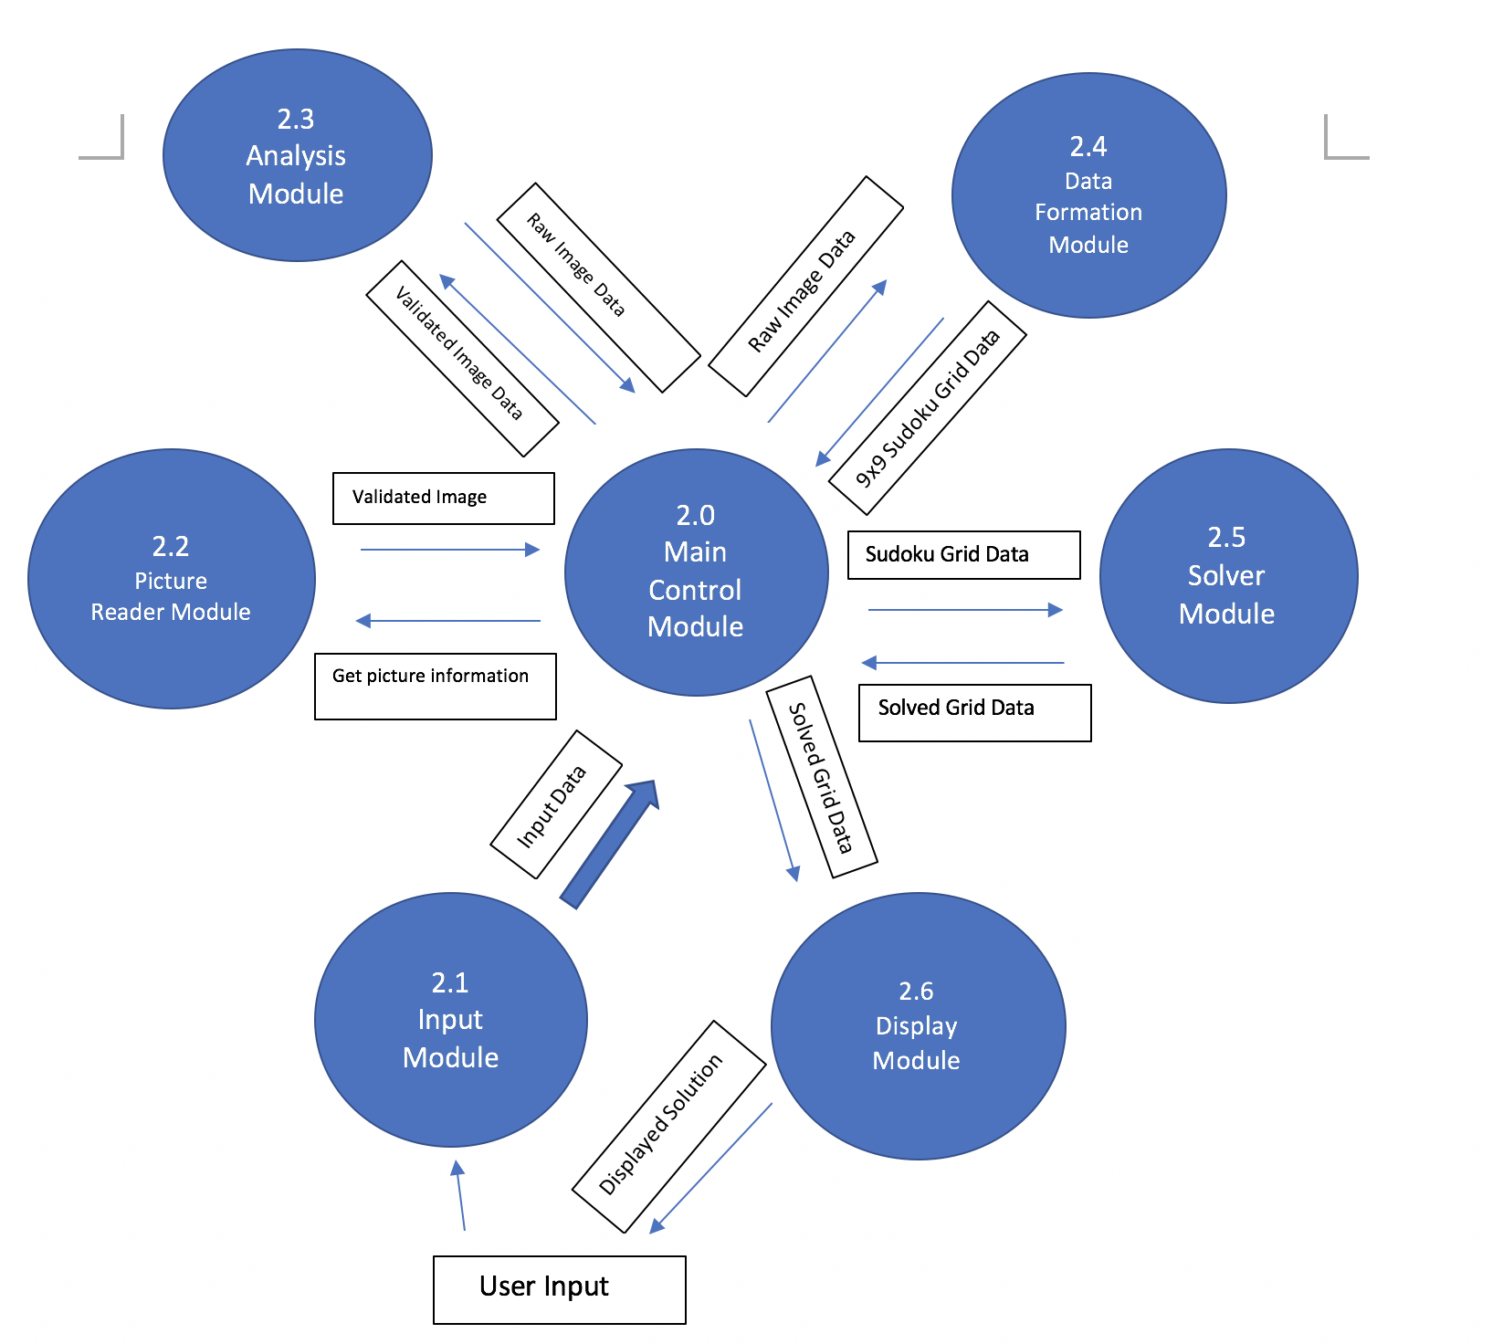

Figure 2.1: Level 1 DFD

2.1.2 Detailed Functional Description of SOLVEDOKU’s Major Units.

The description of SOLVEDOKU’s major functional units shown in Figure 2.1 follows. Most of SOLVEDOKU’s operations depend on the image provided by the user. Image provided can only be a 9x9 grid.

Input - Module 2.1

The Input Module (IM) allows the user to insert the image file for processing.

Picture Reader - Module 2.2

The Picture Reader Module (PRM) validates the image that is entered. If an invalid picture is entered into the program, it rejects the picture. Also, the grid that is entered must contain 17 digits already pre-entered.

Analysis - Module 2.3

The Analysis Module (AM) analyzes the image’s 17 pre-filled digits. The Analysis Module will take the 17 or more pre-filled digits will be extracted from the image and stored.

Data Formulation - Module 2.4

The Data Formulation Module (DFM) processes the extracted image data and stores the data into a data structure.

Solver Module - Module 2.5

The Solver Module (SM) uses backtracking to fill the blank spaces as random digits first. As it fills the puzzle with random digits, collisions shall occur. Through collisions, the Solver Module shall find the digits that do not belong in certain spaces and reject the digit.

Display - Module 2.6

The Display Module (DM) will take the solution of the solved puzzle. Through the solved puzzle, the Display Module will create a visual representation for the user.

3.0 SOLVEDOKU REQUIREMENTS

3.1 SOLVEDOKU Functional Requirements

This Section lists SOLVEDOKU’s functional requirements. This section includes the complete set of functional requirements, along with explanations for cases in which the statement of the requirement was deemed insufficient or requires additional clarification. All requirements relate to the design modules described in Section 2. An effort has been made to standardize the correlation between the design modules and the requirements to make access and organization more consistent. For example, requirement number “n” affecting module 2.1 will be labeled 3.1.n

Requirements Related to Design Module 2.2: Input Module
Requirement No. | Requirement Description
 | Input Module (IM)
3.1.1 | IM shall process inserted data

Requirements Related to Design Module 2.2: Picture Reader Module
Requirement No. | Requirement Description
 | Picture Reader Module (PRM)
3.2.1 | PRM shall validate the image file
3.2.2 | PRM shall reject non 9x9 image grids

Requirements Related to Design Module 2.3: Analysis Module
Requirement No. | Requirement Description
 | Analysis Module (AM)
3.3.1 | AM shall collect Sudoku data from the validated image
3.3.2 | AM shall recognize blank spaces as zeros

Requirements Related to Design Module 2.4: Data Formation Module
Requirement No. | Requirement Description
 | Data Formation Module (DFM)
3.4.1 | DFM shall store Sudoku grid data in a data structure

Requirements Related to Design Module 2.5: Solver Module
Requirement No. | Requirement Description
 | Solver Module (SM)
3.5.1 | SM shall use backtracking
3.5.2 | SM shall populate grid using random digits from 1-9
3.5.3 | SM shall test the random digits against the rules of a Sudoku puzzle
3.5.4 | SM shall reject incorrect digits entered into the puzzle

Requirements Related to Design Module 2.6: Display Module
Requirement No. | Requirement Description
 | Display Module
3.6.1 | SOM shall be able to process the populated data for displaying it
3.6.2 | SOM shall be able to create a visual representation for the user’s interpretation

3.2 SOLVEDOKU Non-Functional Requirements

This Section collects all the SOLVEDOKU’s Non-Functional Requirements. All non-functional requirements are numbered “NF – n” where “n” indicates the n^{th} requirement.

NF - 1 OLYMPIA requires sufficient data storage to store a library of rehearsal recordings as well as machine-read librettos and scores.
NF - 2 OLYMPIA must execute cue events as rapidly as a professional stage crew.
NF - 3 OLYMPIA must be operable by creative professionals who have little technical training.

3.3 SOLVEDOKU Hardware Requirements

This Section collects all SOLVEDOKU’s electronic hardware requirements. All hardware requirements are numbered “H – n” where “n” indicates the n^{th} requirement.

H - 1 SOLVEDOKU will run on standard microcomputer hardware

5.0 SOLVEDOKU’s ELEMENTS OF IMPLEMENTATION

5.1 Introduction

This section descries the implementation of the requirements described above. We include brief descriptions of each of the coded classes. Java code files are included separately.

5.2 Descriptions of Java Classes

Main GUI:

OlympiaGUI is the main GUI and starting point for the program.

Cues and Operas:

The Cue class is used to represent opera cues, which consist of a type (music or user triggered), execution time, and a list of preset themes to be executed at that time. Additional functionality is provided to store and recreate cues from strings, which is used to save the cues to an opera.

The Opera class is used to represent an opera, which consists of a list of cues and the name of the opera. Methods are provided to save the opera to a file, restore an opera from an .olympia file, and add/edit cues in the opera.

Cue Programming:

CueProgrammingGUI handles the creation of the main GUI of the Cue Programming Tab. It creates all of the buttons and necessary components and assigns actions to each of the buttons. The class also handles all of the action. It uses various java layout managers to provide a nice looking layout for the user. This class allows you to program the Cues and save them as an Opera object.

CueProgrammingTable handles the creation of the table where all of the cues are kept so the user can see what has been programmed. All of the actions associated with the table are handled in the CueProgrammingGUI class.

CueProgrammingTree creates the JTree of programmable Cues. It is displayed once the user selects the top level directory of where all the Cues are kept. The Cues are displayed in a tree structure organized into folders according to the type of Cue it is i.e. Lighting, Special Effects, etc. The tree is created dynamically and if a cue is added or deleted from any of the folders, the tree can be refreshed and the changes will be updated accordingly. The tree can also be changed should the user wish to load a different set of Cues.

CustomFile stores the name of a file and the path to that file. It is used instead of a Java File object because when the File object is bound to a Tree Node the toString method is called and the entire path of the File is displayed in the node instead of just the file name. The CustomFile class is used to overcome this implementation issue. It's toString method simply displays the name of the file and this is what the CueProgrammingTree class uses to display on each of the nodes in the tree.

Cue Tracking:

SoundPlayer is a GUI that allows .wav sound files to be played, with significant control over how to play it. The music is loaded into memory at play time, and can be forwarded, rewound, paused, stopped, and resumed. The position of the music is available in milliseconds.

OperaPlayer provides the functionality to the Cue Tracking GUI. It is responsible for sending each preset theme of a cue to the appropriate submodule for handling when that cue's execution time occurs. OperaPlayer interfaces with Lighting, SpecialEffects, Supertitles, and the controls of the Cue Tracking GUI to do this. The opera player's music simulation is done using SoundPlayer. Controls are provided to load an opera; play, pause, and stop it; execute user cues; and create a log when finished. Hardware output is sent to the console textbox, and the current supertitle is sent to the supertitles box.

Lighting:

Light is the basic class. It includes the fundamental elements in the lighting module and it also includes the applyTheme method which is used by the cue.

JColorChooseDemo implements the color module; it extends JFrame and is invoked by LightingGUI. Users can use this class to choose colors.

LightDisplay simulates the combined effect of the lights in GUI. It retrieves the saved light file from specific folder and creates the fallen beams displayed on the GUI.

LightingGUI is the main control GUI, it integrated all the modules (classes). It extends the JFrame and it also includes the presets and saved function. It is integrated into the OlympiaGUI

LightPosition implements the Light Position module. It extends JFrame and is integrated into the LightingGUI. It simulates the light beam which is fallen on the stage. Users can click on the GUI to simulate the beam.

MovingBeam implements the spotlight module. It extends the JFrame and is integrated into the LightGUI. It simulate the moving spot light. As simulation, Users can drag the blue spot to move the position of the spot light.

Special Effects:

SpecialEffectsMain is the top level controlling class for the Special Effects Module.

SFXMachine is an interface implemented by the effects machines and specifying some key methods and attributes used to standardize the machine controls.

AirMachine, Fog Machine, MistMachine, and PyroMachine simulates special effects hardware.

AirSFX, FogSFX, MistSFX, and PyroSFX are the controllers for the machinery listed above.

Supertitles:

SupertitlesMain is the main controller for the Supertitles module

DisplayScreen provides a GUI for patron display screens

Libretto represents the text of an opera. It contains data storage and functionality to construct and iterate through operas.

LibrettoLine represents one line of a libretto, in several languages.

PatronDisplay is the controller for a single patron screen.

